AI ASSISTED CODING
ASSIGNMENT-3.3_1557
NAME:T.TEJASRI
HT NO:2303A51557
BATCH:09
Task 1: AI-Generated Logic for Reading Consumer Details
# Write Python code to read previous units, current units, and customer type, then calculate units consumed
# and the total bill based on the given rates.
def calculate_electricity_bill():
previous_units = int(input("Enter previous meter reading (in units): "))
current_units = int(input("Enter current meter reading (in units): "))
customer_type = input("Enter customer type (residential/commercial): ").strip().lower()

units_consumed = current_units - previous_units
if units_consumed < 0:
print("Error: Current units must be greater than or equal to previous units.")
return

if customer_type == 'residential':
if units_consumed <= 100:
rate = 0.5
elif units_consumed <= 300:
rate = 0.75
else:
rate = 1.0
elif customer_type == 'commercial':
if units_consumed <= 100:
rate = 0.75
elif units_consumed <= 300:
rate = 1.0
else:
rate = 1.5
else:
print("Error: Invalid customer type. Please enter 'residential' or 'commercial'.")
return

total_bill = units_consumed * rate
print(f"Units Consumed: {units_consumed} units")
print(f"Total Bill: ${total_bill:.2f}")
if __name__ == "__main__":
calculate_electricity_bill()
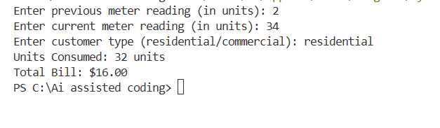
EXPLANATION:
This task reads the previous units, current units, and customer type from the user. It calculates the units consumed by subtracting previous units from current units.
Task 2: Energy Charges Calculation Based on Units Consumed
# Add if-else logic to calculate energy charges for domestic, commercial, and industrial users
def calculate_energy_charges():
previous_units = int(input("Enter previous meter reading (in units): "))
current_units = int(input("Enter current meter reading (in units): "))
customer_type = input("Enter customer type (domestic/commercial/industrial): ").strip().lower()

units_consumed = current_units - previous_units
if units_consumed < 0:
print("Error: Current units must be greater than or equal to previous units.")
return

if customer_type == 'domestic':
if units_consumed <= 100:
rate = 0.6
elif units_consumed <= 300:
rate = 0.8
else:
rate = 1.2
elif customer_type == 'commercial':
if units_consumed <= 100:
rate = 0.9
elif units_consumed <= 300:
rate = 1.2
else:
rate = 1.8
elif customer_type == 'industrial':
if units_consumed <= 100:
rate = 1.0
elif units_consumed <= 300:
rate = 1.5
else:
rate = 2.0
else:
print("Error: Invalid customer type. Please enter 'domestic', 'commercial', or 'industrial'.")
return

total_bill = units_consumed * rate
print(f"Units Consumed: {units_consumed} units")
print(f"Total Bill: ${total_bill:.2f}")
if __name__ == "__main__":
calculate_energy_charges()

# Optimize tariff calculation using conditional statements
def optimized_tariff_calculation():
previous_units = int(input("Enter previous meter reading (in units): "))
current_units = int(input("Enter current meter reading (in units): "))
customer_type = input("Enter customer type (residential/commercial/industrial): ").strip().lower()

units_consumed = current_units - previous_units
if units_consumed < 0:
print("Error: Current units must be greater than or equal to previous units.")
return

rates = {
'residential': [(100, 0.5), (300, 0.75), (float('inf'), 1.0)],
'commercial': [(100, 0.75), (300, 1.0), (float('inf'), 1.5)],
'industrial': [(100, 1.0), (300, 1.5), (float('inf'), 2.0)]
}

if customer_type not in rates:
print("Error: Invalid customer type. Please enter 'residential', 'commercial', or 'industrial'.")
return

for limit, rate in rates[customer_type]:
if units_consumed <= limit:
total_bill = units_consumed * rate
break
print(f"Units Consumed: {units_consumed} units")
print(f"Total Bill: ${total_bill:.2f}")
if __name__ == "__main__":
optimized_tariff_calculation()
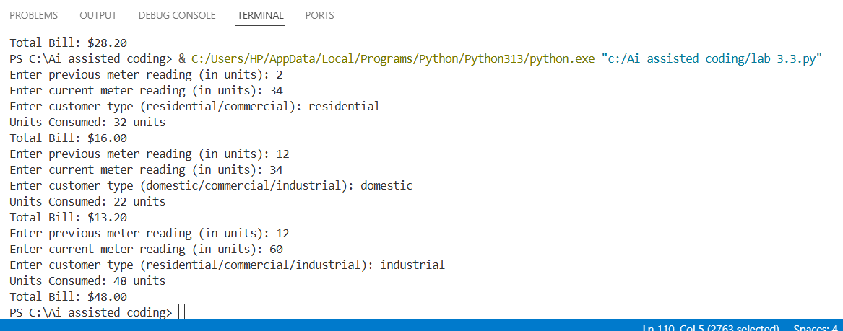
EXPLANATION:
This task calculates energy charges based on the customer type using conditional statements. Different rates are applied for domestic, commercial, and industrial users.
Task 3: Modular Design Using AI Assistance (Using Functions)
# Create Python functions to calculate energy charges and fixed charges
def calculate_energy_and_fixed_charges():
previous_units = int(input("Enter previous meter reading (in units): "))
current_units = int(input("Enter current meter reading (in units): "))
customer_type = input("Enter customer type (residential/commercial/industrial): ").strip().lower()

units_consumed = current_units - previous_units
if units_consumed < 0:
print("Error: Current units must be greater than or equal to previous units.")
return

energy_rates = {
'residential': [(100, 0.5), (300, 0.75), (float('inf'), 1.0)],
'commercial': [(100, 0.75), (300, 1.0), (float('inf'), 1.5)],
'industrial': [(100, 1.0), (300, 1.5), (float('inf'), 2.0)]
}

fixed_charges = {
'residential': 50,
'commercial': 100,
'industrial': 150
}

if customer_type not in energy_rates or customer_type not in fixed_charges:
print("Error: Invalid customer type. Please enter 'residential', 'commercial', or 'industrial'.")
return

for limit, rate in energy_rates[customer_type]:
if units_consumed <= limit:
energy_charge = units_consumed * rate
break

total_bill = energy_charge + fixed_charges[customer_type]

print(f"Units Consumed: {units_consumed} units")
print(f"Energy Charge: ${energy_charge:.2f}")
print(f"Fixed Charge: ${fixed_charges[customer_type]:.2f}")
print(f"Total Bill: ${total_bill:.2f}")
if __name__ == "__main__":
calculate_energy_and_fixed_charges()

# Write reusable billing functions with comments
def calculate_energy_and_fixed_charges():
"""
Calculate the energy charges and fixed charges based on customer type and units consumed.
"""
previous_units = int(input("Enter previous meter reading (in units): "))
current_units = int(input("Enter current meter reading (in units): "))
customer_type = input("Enter customer type (residential/commercial/industrial): ").strip().lower()

units_consumed = current_units - previous_units
if units_consumed < 0:
print("Error: Current units must be greater than or equal to previous units.")
return

energy_rates = {
'residential': [(100, 0.5), (300, 0.75), (float('inf'), 1.0)],
'commercial': [(100, 0.75), (300, 1.0), (float('inf'), 1.5)],
'industrial': [(100, 1.0), (300, 1.5), (float('inf'), 2.0)]
}

fixed_charges = {
'residential': 50,
'commercial': 100,
'industrial': 150
}

if customer_type not in energy_rates or customer_type not in fixed_charges:
print("Error: Invalid customer type. Please enter 'residential', 'commercial', or 'industrial'.")
return

for limit, rate in energy_rates[customer_type]:
if units_consumed <= limit:
energy_charge = units_consumed * rate
break

total_bill = energy_charge + fixed_charges[customer_type]

print(f"Units Consumed: {units_consumed} units")
print(f"Energy Charge: ${energy_charge:.2f}")
print(f"Fixed Charge: ${fixed_charges[customer_type]:.2f}")
print(f"Total Bill: ${total_bill:.2f}")
if __name__ == "__main__":
calculate_energy_and_fixed_charges()
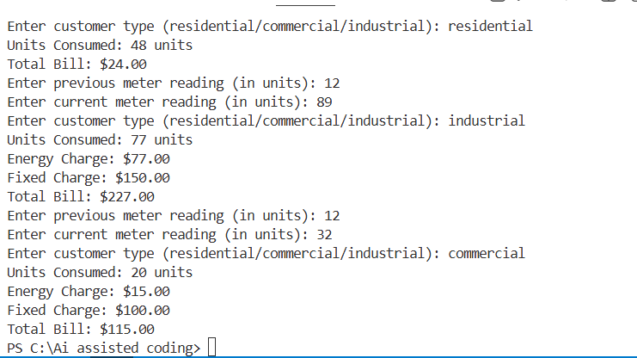
EXPLANATION:
This task uses user-defined functions to calculate energy charges and fixed charges. It makes the program reusable and easy to understand
Task 4: Calculation of Additional Charges
# Add fixed charges, customer charges, and electricity duty calculation
def calculate_detailed_electricity_bill():
previous_units = int(input("Enter previous meter reading (in units): "))
current_units = int(input("Enter current meter reading (in units): "))
customer_type = input("Enter customer type (residential/commercial/industrial): ").strip().lower()

units_consumed = current_units - previous_units
if units_consumed < 0:
print("Error: Current units must be greater than or equal to previous units.")
return

energy_rates = {
'residential': [(100, 0.5), (300, 0.75), (float('inf'), 1.0)],
'commercial': [(100, 0.75), (300, 1.0), (float('inf'), 1.5)],
'industrial': [(100, 1.0), (300, 1.5), (float('inf'), 2.0)]
}

fixed_charges = {
'residential': 50,
'commercial': 100,
'industrial': 150
}

customer_charges = {
'residential': 20,
'commercial': 40,
'industrial': 60
}

electricity_duty_rate = 0.05 # 5% electricity duty

if customer_type not in energy_rates or customer_type not in fixed_charges or customer_type not in customer_charges:
print("Error: Invalid customer type. Please enter 'residential', 'commercial', or 'industrial'.")
return

for limit, rate in energy_rates[customer_type]:
if units_consumed <= limit:
energy_charge = units_consumed * rate
break

fixed_charge = fixed_charges[customer_type]
customer_charge = customer_charges[customer_type]
electricity_duty = (energy_charge + fixed_charge + customer_charge) * electricity_duty_rate

total_bill = energy_charge + fixed_charge + customer_charge + electricity_duty

print(f"Units Consumed: {units_consumed} units")
print(f"Energy Charge: ${energy_charge:.2f}")
print(f"Fixed Charge: ${fixed_charge:.2f}")
print(f"Customer Charge: ${customer_charge:.2f}")
print(f"Electricity Duty: ${electricity_duty:.2f}")
print(f"Total Bill: ${total_bill:.2f}")
if __name__ == "__main__":
calculate_detailed_electricity_bill()

# Improve billing accuracy by including additional charges
def calculate_comprehensive_electricity_bill():
"""
Calculate a comprehensive electricity bill including energy charges, fixed charges,
customer charges, and electricity duty based on customer type and units consumed.
"""
previous_units = int(input("Enter previous meter reading (in units): "))
current_units = int(input("Enter current meter reading (in units): "))
customer_type = input("Enter customer type (residential/commercial/industrial): ").strip().lower()

units_consumed = current_units - previous_units
if units_consumed < 0:
print("Error: Current units must be greater than or equal to previous units.")
return

energy_rates = {
'residential': [(100, 0.5), (300, 0.75), (float('inf'), 1.0)],
'commercial': [(100, 0.75), (300, 1.0), (float('inf'), 1.5)],
'industrial': [(100, 1.0), (300, 1.5), (float('inf'), 2.0)]
}

fixed_charges = {
'residential': 50,
'commercial': 100,
'industrial': 150
}

customer_charges = {
'residential': 20,
'commercial': 40,
'industrial': 60
}

electricity_duty_rate = 0.05 # 5% electricity duty

if customer_type not in energy_rates or customer_type not in fixed_charges or customer_type not in customer_charges:
print("Error: Invalid customer type. Please enter 'residential', 'commercial', or 'industrial'.")
return

for limit, rate in energy_rates[customer_type]:
if units_consumed <= limit:
energy_charge = units_consumed * rate
break

fixed_charge = fixed_charges[customer_type]
customer_charge = customer_charges[customer_type]
electricity_duty = (energy_charge + fixed_charge + customer_charge) * electricity_duty_rate

total_bill = energy_charge + fixed_charge + customer_charge + electricity_duty

print(f"Units Consumed: {units_consumed} units")
print(f"Energy Charge: ${energy_charge:.2f}")
print(f"Fixed Charge: ${fixed_charge:.2f}")
print(f"Additional Customer Charge: ${customer_charge:.2f}")
print(f"Customer Charge: ${customer_charge:.2f}")
print(f"Electricity Duty: ${electricity_duty:.2f}")
print(f"Total Bill: ${total_bill:.2f}")
if __name__ == "__main__":
calculate_comprehensive_electricity_bill()
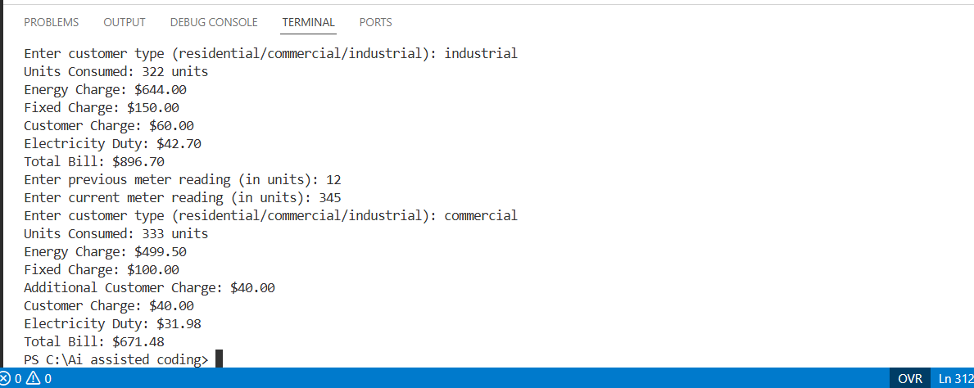
EXPLANTION:
This task adds extra charges like fixed charges, customer charges, and electricity duty. It improves billing accuracy by including all required charges.

Task 5: Final Bill Generation and Output Analysis
# Generate formatted electricity bill output with total amount
def generate_electricity_bill():
previous_units = int(input("Enter previous meter reading (in units): "))
current_units = int(input("Enter current meter reading (in units): "))
customer_type = input("Enter customer type (residential/commercial/industrial): ").strip().lower()

units_consumed = current_units - previous_units
if units_consumed < 0:
print("Error: Current units must be greater than or equal to previous units.")
return

energy_rates = {
'residential': [(100, 0.5), (300, 0.75), (float('inf'), 1.0)],
'commercial': [(100, 0.75), (300, 1.0), (float('inf'), 1.5)],
'industrial': [(100, 1.0), (300, 1.5), (float('inf'), 2.0)]
}

fixed_charges = {
'residential': 50,
'commercial': 100,
'industrial': 150
}

customer_charges = {
'residential': 20,
'commercial': 40,
'industrial': 60
}

electricity_duty_rate = 0.05 # 5% electricity duty

if customer_type not in energy_rates or customer_type not in fixed_charges or customer_type not in customer_charges:
print("Error: Invalid customer type. Please enter 'residential', 'commercial', or 'industrial'.")
return

for limit, rate in energy_rates[customer_type]:
if units_consumed <= limit:
energy_charge = units_consumed * rate
break

fixed_charge = fixed_charges[customer_type]
customer_charge = customer_charges[customer_type]
electricity_duty = (energy_charge + fixed_charge + customer_charge) * electricity_duty_rate

total_bill = energy_charge + fixed_charge + customer_charge + electricity_duty

print("\n----- Electricity Bill -----")
print(f"Customer Type : {customer_type.capitalize()}")
print(f"Previous Reading : {previous_units} units")
print(f"Current Reading : {current_units} units")
print(f"Units Consumed : {units_consumed} units")
print(f"Energy Charge : ${energy_charge:.2f}")
print(f"Fixed Charge : ${fixed_charge:.2f}")
print(f"Customer Charge : ${customer_charge:.2f}")
print(f"Electricity Duty : ${electricity_duty:.2f}")
print(f"Total Amount Payable: ${total_bill:.2f}")
print("----------------------------")
if __name__ == "__main__":
generate_electricity_bill()
# Display EC, FC, CC, ED, and total bill neatly
def display_detailed_electricity_bill():
"""
Display a detailed electricity bill including energy charges, fixed charges,
customer charges, electricity duty, and total amount payable.
"""
previous_units = int(input("Enter previous meter reading (in units): "))
current_units = int(input("Enter current meter reading (in units): "))
customer_type = input("Enter customer type (residential/commercial/industrial): ").strip().lower()

units_consumed = current_units - previous_units
if units_consumed < 0:
print("Error: Current units must be greater than or equal to previous units.")
return

energy_rates = {
'residential': [(100, 0.5), (300, 0.75), (float('inf'), 1.0)],
'commercial': [(100, 0.75), (300, 1.0), (float('inf'), 1.5)],
'industrial': [(100, 1.0), (300, 1.5), (float('inf'), 2.0)]
}

fixed_charges = {
'residential': 50,
'commercial': 100,

'industrial': 150
}

customer_charges = {
'residential': 20,
'commercial': 40,
'industrial': 60
}

electricity_duty_rate = 0.05 # 5% electricity duty

if customer_type not in energy_rates or customer_type not in fixed_charges or customer_type not in customer_charges:
print("Error: Invalid customer type. Please enter 'residential', 'commercial', or 'industrial'.")
return

for limit, rate in energy_rates[customer_type]:
if units_consumed <= limit:
energy_charge = units_consumed * rate
break

fixed_charge = fixed_charges[customer_type]
customer_charge = customer_charges[customer_type]
electricity_duty = (energy_charge + fixed_charge + customer_charge) * electricity_duty_rate

total_bill = energy_charge + fixed_charge + customer_charge + electricity_duty

print("\n----- Detailed Electricity Bill -----")
print(f"Customer Type : {customer_type.capitalize()}")
print(f"Previous Reading : {previous_units} units")
print(f"Current Reading : {current_units} units")
print(f"Units Consumed : {units_consumed} units")
print(f"Energy Charge (EC) : ${energy_charge:.2f}")
print(f"Fixed Charge (FC) : ${fixed_charge:.2f}")
print(f"Customer Charge (CC): ${customer_charge:.2f}")
print(f"Electricity Duty (ED): ${electricity_duty:.2f}")
print(f"Total Amount Payable: ${total_bill:.2f}")
print("-------------------------------------")
if __name__ == "__main__":
display_detailed_electricity_bill()
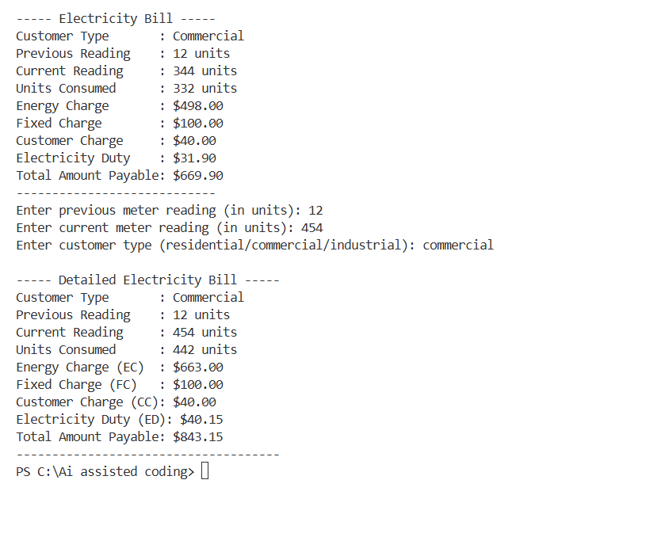
EXPLANATION:
This task calculates the total bill by adding all charges and displays them neatly. It also analyzes the program for correctness, readability, and real-world use.

